Customer Churn Prediction Project Documentation

Index
- Project Overview
- Exploratory Data Analysis
- Step 1: Data Ingestion & Missing Value Handling
- Step 2: Variable Transformation
- Step 3: Outlier Handling
- Step 4: Categorical Encoding
- Step 5: Feature Selection
- Step 6: Data Balancing
- Step 7: Feature Scaling
- Step 8: Model Selection & Hyperparameter Tuning

Project Overview
This project aims to predict customer churn in a telecom environment using a fully automated, data-driven machine learning pipeline. Each preprocessing and modelling step dynamically selects the best technique based on statistical performance and business relevance.

Exploratory Data Analysis
This project uses exploratory data analysis (EDA) and visualization techniques as the first analytical step, before building any machine learning models. The goal is to understand churn behaviour, identify high-risk customer segments, and guide feature engineering and model design decisions.
Visualizations are used to:
- Identify churn patterns
- Understand customer behaviour
- Highlight high-risk customer segments
- Support data-driven business decisions

Dataset Description
The dataset contains customer-level information from a telecom service provider. Each row represents one customer, with features describing demographics, services, billing, and churn status.

Key Features:
- CustomerID – Unique customer identifier
- Gender – Male or Female
- SeniorCitizen – Senior citizen indicator
- Tenure – Number of months with the company
- Contract – Contract type (Month-to-month, One year, Two year)
- InternetService – Type of internet service
- MonthlyCharges – Monthly billing amount
- PaymentMethod – Mode of payment
- TelecomPartner – Partner network
- Churn – Target variable (Yes/No)

The dataset includes both categorical and numerical variables, making it suitable for exploratory visualization and predictive modeling.
Visualizations
1. Customer Churn Distribution:
Description: Displays the overall proportion of churned vs non-churned customers.
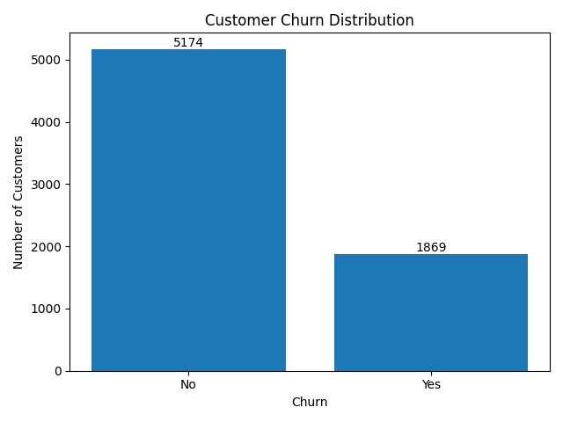

Insights:
- Majority of customers do not churn
- A significant portion of customers leave the service
Business Impact:
Even moderate churn can cause substantial revenue loss, emphasizing the need for churn prediction.

2. Contract Type vs Churn
Description: Shows churn behaviour across different contract types.

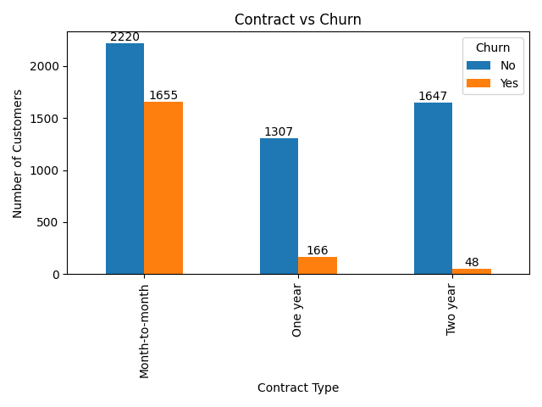

Insights:
- Month-to-month customers have the highest churn
- Long-term contracts show lower churn
Business Impact:
Encouraging long-term contracts improves retention stability.

3. Gender vs Churn
Description: Compares churn rates between male and female customers.

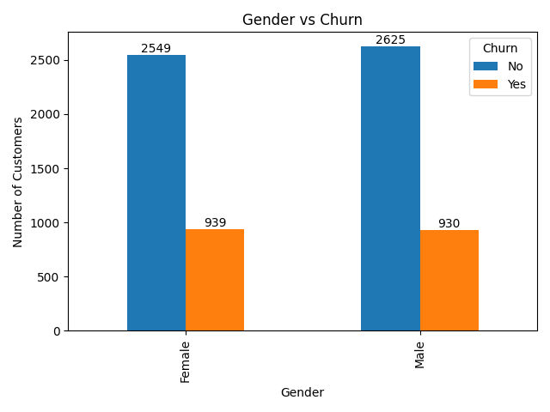
Insights:
- Nearly identical churn rates across genders
Business Impact:
Gender is not a strong churn driver; focus should remain on service quality and pricing.

4. Internet Service vs Gender
Description: Distribution of internet service types across genders.

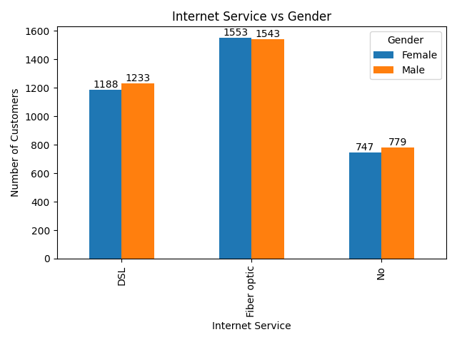
Insights:
- Fiber optic dominates for both genders
- Minimal demographic variation
Business Impact:
Service improvement is more impactful than demographic targeting.

5. Monthly Charges vs Churn
Description: Analyses churn across different billing levels.
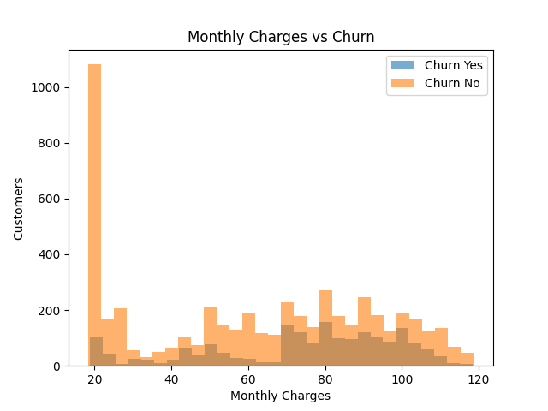
Insights:
- Higher monthly charges correlate with higher churn
- Lower-paying customers stay longer
Business Impact:
Flexible pricing and loyalty discounts can reduce churn among high-paying customers.

6. Payment Method vs Churn
Description: Examines churn by payment method.

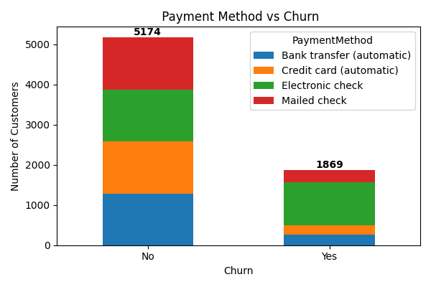
Insights:
- Electronic check users show higher churn
- Automatic payments show better retention
Business Impact:
Promoting auto-payment methods can improve customer retention.

7. Churn Among Senior Citizens by Gender
Description: Focuses on churn patterns among senior citizens by gender.

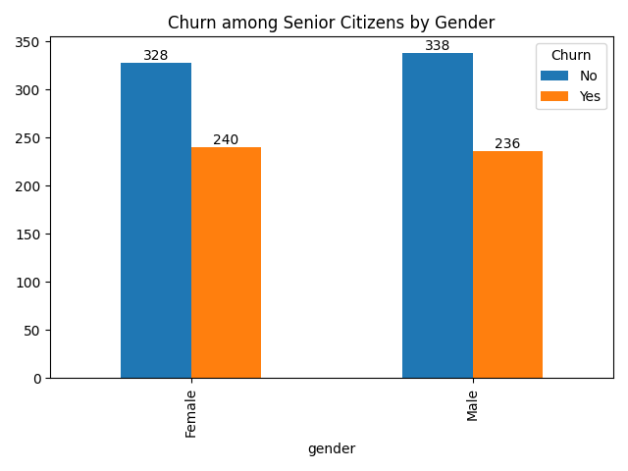
Insights:
- Seniors have relatively higher churn
- Minimal gender differences
Business Impact:
Senior-friendly plans and dedicated support can reduce churn.

8. Telecom Partner vs Churn
Description: Compares churn rates across telecom partners.

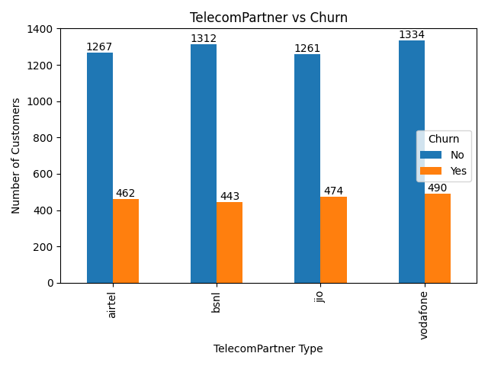
Insights:
- Some partners exhibit higher churn
Business Impact:
Partner-level performance analysis is essential for churn mitigation.

9. Tenure vs Churn
Description: Shows churn behaviour across customer tenure.

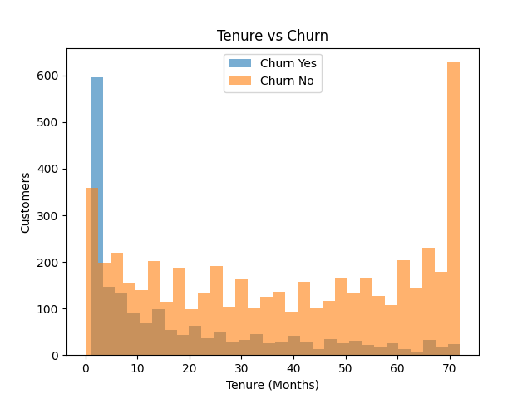
Insights:
- Most churn occurs in early months
- Long-tenure customers are more loyal
Business Impact:
Improving onboarding and early engagement is critical for retention.

Overall, EDA Conclusion
Exploratory analysis shows that churn is primarily influenced by:
- Contract type
- Tenure
- Monthly charges
- Payment method
Demographic variables such as gender have minimal impact. These insights directly informed feature selection, transformation strategies, and model choice in the subsequent ML pipeline.
Data Preprocessing

Step 1: Data Ingestion & Missing Value Handling
Project Context
This project focuses on predicting customer churn for a telecom company using machine learning. The first step of the ML pipeline is responsible for loading raw data, performing basic preprocessing, splitting the dataset, and handling missing values in a data-driven way. This step is implemented mainly in main.py and missing_values.py.
Data Ingestion
Objective
Load the Telco Customer Churn dataset and prepare it for downstream preprocessing and modelling.
Implementation (main.py → CustomerChurn.__init__)
1.1 Reading the Dataset
- The dataset is read using Pandas from a CSV file:
- self.df = pd.read_csv(self.path)
- Logging is used to track successful data loading and dataset shape.
1.2 Synthetic Feature Creation
- A new categorical feature telecom_partner is generated using random assignment:
  - Values: ['Jio', 'Airtel', 'BSNL', 'Vodafone']
  - This simulates real-world partner segmentation.
1.3 Initial Cleaning & Type Handling
- customerID is dropped as it has no predictive value.
- TotalCharges is converted to numeric:
- self.df['TotalCharges'] = pd.to_numeric(self.df['TotalCharges'], errors='coerce')
  - Invalid values are converted into missing values (NaN).
- Target variable Churn is encoded:
  - Yes → 1, No → 0
1.4 Feature–Target Split
- Independent variables (X) and target (y) are separated:
- self.X = self.df.iloc[:, :-1]
- self.y = self.df.iloc[:, -1]
1.5 Train–Test Split
- Data is split using an 80:20 ratio:
- train_test_split(test_size=0.2, random_state=42)
- This ensures:
  - No data leakage
  - Consistent evaluation

Missing Value Handling
Objective
Handle missing values after train–test split using the best imputation technique per feature, selected automatically.
Why After Split?
- Prevents data leakage
- Ensures realistic model performance

Missing Value Techniques (missing_values.py)
The project implements multiple imputation strategies inside the MISSING_VALUE_TECHNIQUES class. Each technique is designed to handle missing data under different statistical assumptions.
Available Techniques and Explanations
1. Mean Imputation
Replaces missing values with the arithmetic mean of the feature calculated from the training data. It is simple and fast but works best when the data is normally distributed and does not contain extreme outliers.
| Mean Imputation | Replaces missing values with column mean (numeric) |
2. Median Imputation
Uses the median of the training feature to fill missing values. This method is more robust than mean imputation and is preferred when the data contains outliers or is skewed.
| Median Imputation | Uses column median (robust to outliers) |
3. Mode Imputation
Fills missing values using the most frequently occurring value in the feature. It is commonly used for categorical variables where numerical statistics like mean or median are not meaningful.
| Mode Imputation | Uses most frequent value (categorical) |
4. End of Distribution (EOD) Imputation
Replaces missing values with an extreme value (Mean + 3 × Standard Deviation). This technique preserves the information that the value was missing and is useful when missingness itself may carry predictive importance.
| End of Distribution | Mean + 3×Std (captures extreme cases) |
5. Forward Fill (FFill)
Propagates the previous valid observation forward. This approach is mainly suitable for ordered or time-dependent data where consecutive values are related.
| Forward Fill | Propagates previous value |
6. Backward Fill (BFill)
Uses the next valid observation to fill missing values. Similar to forward fill, it is useful when data has a logical order and future values can reasonably estimate missing past values.
| Backward Fill | Uses next valid value |
7. Random Sample Imputation
Randomly replaces missing values by sampling from the existing (non-missing) values of the same feature. This method helps preserve the original data distribution and variance better than mean or median imputation.
| Random Sample | Randomly samples from observed values |
Each method:
- Works independently on train and test sets
- Logs missing counts before and after imputation

Why These Techniques Are Selected Automatically
Instead of applying a single imputation strategy globally, this project automatically selects the best missing value technique for each feature. This is crucial in real-world telecom churn data because different features represent different business behaviours.
Selection Logic
- Numeric Features:
The technique that causes the least change in variance is selected. This ensures customer behaviour patterns such as usage, charges, or tenure are not artificially distorted.
- Categorical Features:
The technique that most effectively reduces missing values is selected, ensuring minimal information loss for customer attributes like contract type or payment method.
This adaptive strategy mimics how a data scientist would evaluate imputation choices feature-by-feature rather than relying on assumptions.

Pros, Cons, and Telecom Churn Context
1. Mean Imputation
Pros:
- Simple and computationally efficient
- Works well for normally distributed numeric features
Cons:
- Sensitive to outliers
- Reduces variance
Telecom Context:
Useful for features like average monthly charges where values are stable across customers.

2. Median Imputation
Pros:
- Robust to outliers
- Preserves central tendency better than mean
Cons:
- Still reduces variance
- May ignore subtle distribution patterns
Telecom Context:
Effective for skewed features such as total charges, where a few long-tenure customers may have extremely high values.

3. Mode Imputation
Pros:
- Best suited for categorical variables
- Maintains valid category values
Cons:
- Can introduce bias toward majority class
Telecom Context:
Commonly used for contract type, internet service, or payment method when a dominant customer preference exists.

4. End of Distribution (EOD) Imputation
Pros:
- Preserves information about missingness
- Highlights abnormal or rare behaviour
Cons:
- Introduces artificial extreme values
- Requires careful interpretation
Telecom Context:
Helpful when missing values may indicate unusual customers, such as high-risk churn users with incomplete billing records.

5. Forward Fill
Pros:
- Maintains continuity in ordered data
- Simple to implement
Cons:
- Not suitable for independent records
Telecom Context:
Applicable when customer data is collected sequentially over time, such as rolling service usage metrics.

6. Backward Fill
Pros:
- Uses future information effectively
- Complements forward fill
Cons:
- Can introduce look-ahead bias if misused
Telecom Context:
Useful when missing customer attributes are later corrected, such as updated contract details.

7. Random Sample Imputation
Pros:
- Preserves original distribution and variance
- Reduces imputation bias
Cons:
- Adds randomness
- Less interpretable
Telecom Context:
Well-suited for behavioral features like monthly usage or call duration, where customer behavior is naturally diverse.

Automatic Technique Selection (`main.py` → `missing_value_handler`)

Workflow
1. Identify columns with missing values:
missing_cols = self.X_train.columns[self.X_train.isnull().any()]

2. For each column, apply all imputation techniques

3. Evaluation Criteria:

Numeric features→ minimize variance distortion
score = |original_variance − new_variance|

Categorical features → maximize missing value reduction

4. Select the best technique (minimum score) per column

5. Apply the selected method to both train and test data

6. Store decisions in:

self.best_imputation[col] = best_tech

Outputs of Missing Value Handling

- Cleaned `X_train` and `X_test` with **no missing values**
- Missing value handling is:
* Feature‑specific
* Data‑driven
* Logged for reproducibility

These processed datasets are then passed to the next pipeline steps:
* Variable transformation
* Outlier handling
* Encoding
* Feature selection
Key Design Decisions
* Missing value handling occurs **after splitting** → avoids leakage
* Multiple imputation strategies are evaluated automatically
* Statistical criteria are used instead of manual assumptions
* Full logging ensures transparency and debugging support

Step 2: Variable Transformation
Objective
The goal is to transform numerical features so that they:
- Have comparable scales
- Exhibit reduced skewness
- Better satisfy model assumptions (especially for distance-based and linear models)
This step is implemented in:
- main.py → variable_transform()
- variable_transformation_technique.py
All transformations are applied after train–test split to avoid data leakage.

1. Feature Separation
Before transformation, features are divided into:
- Numerical features → eligible for transformation
- Categorical features → left unchanged at this stage
X_train_num = self.X_train.select_dtypes(exclude='object')
X_train_cat = self.X_train.select_dtypes(include='object')
Only numerical columns are evaluated across different transformation techniques.

Workflow of Variable Transformation:
- Split features into numerical and categorical columns
- Select only numerical features for transformation
- Apply all available transformation techniques to each numerical feature
- Compute skewness for every transformed feature
- Select the technique that produces minimum skewness
- Apply the selected transformation to both train and test sets
- Recombine transformed numerical features with untouched categorical features
This workflow ensures each feature is optimally transformed based on its distribution.

Available Variable Transformation Techniques
Each numerical feature is independently tested using the following methods:
1. Standard Scaling
Description:
Centers data to mean = 0 and standard deviation = 1.
Best Used When:
- Data is approximately normally distributed
- Models are sensitive to feature scale (Logistic Regression, SVM)
Telecom Context:
Useful for features like tenure where values vary widely but follow a stable distribution.

2. Min–Max Scaling
Description:
Scales values to a fixed range [0, 1].
Best Used When:
- Bounded features
- Neural networks or distance-based algorithms
Telecom Context:
Applicable to features such as monthly charges when preserving relative proportions is important.

3. Robust Scaling
Description:
Uses median and interquartile range (IQR) instead of mean and variance.
Best Used When:
- Data contains outliers
Telecom Context:
Effective for total charges, where long-tenure customers can create extreme values.

4. Log Transformation
Description:
Applies log(1 + x) to reduce right skewness.
Best Used When:
- Data is positively skewed
- Values are non-negative
Telecom Context:
Useful for usage-related features such as data consumption or call duration.

5. Power Transformation (Yeo–Johnson)
Description:
Transforms data to be more Gaussian-like while supporting zero and negative values.
Best Used When:
- Strong skewness exists
- Data includes zero or negative values
Telecom Context:
Effective for diverse customer behaviour metrics where distributions are highly irregular.

6. Box–Cox Transformation
Description:
Applies a power transform that strictly requires positive values.
Best Used When:
- Strong skewness
- All values > 0
Telecom Context:
Suitable for strictly positive monetary features like billing amounts.

7. Quantile Transformation
Description:
Maps the data to a normal distribution using quantiles.
Best Used When:
- Severe skewness
- Non-linear distributions
Telecom Context:
Helpful when customer usage patterns vary drastically across segments.

3. Automatic Selection of the Best Transformation
Selection Logic (Implemented in main.py)
For each numerical feature:
- Apply all transformation techniques
- Compute absolute skewness after transformation
score = |skewness|
- Select the technique that minimizes skewness
best_technique = min(skewness_scores, key=skewness_scores.get)

Why the Selected Technique Is the Best
Selected Technique (Per Feature): Transformation with minimum post-transformation skewness
In this project, the best transformation technique is selected independently for each numerical feature based on skewness reduction.
Why This Is Best
- Skewed features violate assumptions of linear and distance-based models
- Minimizing skewness makes feature distributions closer to normal
- Improves model convergence and stability
- Preserves business interpretability by avoiding unnecessary transformations
This feature-wise selection ensures that each telecom attribute (e.g., tenure, charges, usage) is transformed in the most statistically appropriate way.
- Skewness directly affects model performance by influencing:
  - Gradient stability
  - Distance calculations
  - Linear decision boundaries
- Minimizing skewness:
  - Makes feature distributions closer to Gaussian
  - Improves convergence of Logistic Regression
  - Enhances separation between churn and non-churn customers
- Selecting transformations per feature avoids:
  - Over-scaling
  - Loss of business meaning
  - One-size-fits-all assumptions

Output of Variable Transformation:
After completing variable transformation:
- All numerical features are optimally scaled or transformed
- Skewness is minimized on a per-feature basis
- Feature distributions are closer to Gaussian
- Categorical features remain unchanged
- Output datasets:
  - self.X_train → transformed numerical + original categorical features
  - self.X_test → transformed numerical + original categorical features
These outputs ensure the data is well-conditioned for outlier detection and downstream modelling.

Step 3: Outlier Handling
Objective
The objective is to detect and handle extreme values (outliers) in numerical features that can negatively impact model performance, skew distributions, and distort decision boundaries.
This step is implemented in:
- main.py → outliers ()
- outliers_techniques.py
Outlier handling is applied after variable transformation and before categorical encoding.

Workflow of Outlier Handling:
- Separate numerical and categorical features
- Detect outliers in numerical features using the IQR method
- Count number of outliers before applying any treatment
- Apply each outlier handling technique independently
- Recount outliers after applying each technique
- Select the technique that results in the minimum remaining outliers
- Apply the selected technique to both train and test sets
- Recombine numerical and categorical features
This workflow balances robustness with preservation of real customer behaviour.

Outlier Detection Strategy
Outliers are evaluated using the Interquartile Range (IQR) method:
Outlier < Q1 − 1.5 × IQR or Outlier > Q3 + 1.5 × IQR
For each numerical feature:
- Outliers are counted before applying any technique
- Each technique is evaluated based on how many outliers remain
The technique that results in the minimum number of outliers is selected.

Outlier Handling Techniques
1. Winsorization
Description:
Caps extreme values at lower and upper IQR boundaries instead of removing them.
Pros:
- Reduces the effect of extreme values
- Preserves dataset size
Cons:
- Alters original values
Telecom Context:
Useful for features like monthly charges, where a few customers may have unusually high bills.

2. Robust Scaling
Description:
Scales features using the median and IQR, making it insensitive to outliers.
Pros:
- Strong resistance to outliers
- Maintains relative ordering
Cons:
- Does not remove outliers, only reduces impact
Telecom Context:
Effective for total charges affected by long-tenure customers.

3. Log Transformation
Description:
Applies log(1+x) to compress large values and reduce right skewness.
Pros:
- Reduces skew
- Handles wide value ranges
Cons:
- Only works for non-negative values
Telecom Context:
Applicable to usage-based features such as call duration or data consumption.

4. No Outlier Handling
Description:
Leaves the data unchanged.
Pros:
- No information loss
Cons:
- Risk of model distortion
Telecom Context:
Used when outliers represent legitimate high-value customers.

Why the Selected Outlier Technique Is Best
Selected Technique (Per Feature): Method that results in the minimum remaining IQR-based outliers
For each numerical feature, all outlier-handling techniques are evaluated and the one leaving the fewest detected outliers is selected.

Why This Is Best
- Directly targets extreme values that distort model learning
- Avoids unnecessary removal of valid customer records
- Balances robustness with realistic telecom behaviour
- Prevents models from overfitting to rare extreme cases

This ensures that high-billing or high-usage customers are handled carefully without losing important churn signals.
- The selected method minimizes the number of detected outliers per feature
- Prevents excessive distortion of customer behaviour
- Balances robustness with business realism
- Ensures models are not overly influenced by rare extreme cases

Output of Outlier Handling

After outlier handling:
- Extreme values are either capped, scaled, or compressed
- Number of statistical outliers is minimized per feature
- Dataset size remains unchanged (no row removal)
- Feature distributions are more stable and less skewed
- Output datasets:
  - self.X_train → outlier-treated numerical + categorical features
  - self.X_test → outlier-treated numerical + categorical features
These outputs reduce model sensitivity to abnormal customer behaviour while preserving business realism.

Step 4: Categorical Encoding (Cat-to-Num Transformation)
Objective
Convert categorical variables into numerical representations that machine learning models can process effectively.
This step is implemented in:
- main.py → cat_to_num()
- cat_to_num_Techniques.py

Workflow of Categorical Encoding
- Identify all categorical features
- Apply multiple encoding techniques independently to each feature
- Measure the number of columns generated by each encoding
- Select the encoding technique with the fewest generated columns
- Apply the selected encoding to train and test sets
- Concatenate encoded categorical features with numerical features
This workflow ensures efficient representation of categorical data without dimensional explosion.

Why Encoding Is Necessary
Machine learning models operate on numerical inputs. Categorical features such as contract type, payment method, or internet service must be encoded without losing business meaning.

Encoding Techniques Evaluated
Each categorical feature is evaluated independently using multiple encoding strategies.
1. Label Encoding
Description: Assigns an integer value to each category.
Pros:
- Simple and fast
Cons:
- Introduces artificial order
Telecom Context:
Useful for low-cardinality features with implicit order.

2. One-Hot Encoding
Description:
Creates binary columns for each category.
Pros:
- No ordinal assumptions
Cons:
- Increases dimensionality
Telecom Context:
Effective for features like gender or senior citizen.

3. Frequency Encoding
Description:
Replaces categories with their frequency counts.
Pros:
- Preserves importance of common categories
- Low dimensionality
Cons:
- Loses category identity
Telecom Context:
Useful for payment methods with dominant usage patterns.

4. Binary Encoding
Description:
Encodes categories into binary digits.
Pros:
- Handles high-cardinality features efficiently
Cons:
- Less interpretable
Telecom Context:
Applicable to features with many unique values.

5. Ordinal Encoding
Description: Encodes categories based on a predefined order.
Pros:
- Preserves meaningful hierarchy
Cons:
- Requires domain knowledge
Telecom Context:
Highly suitable for contract duration (Month-to-month < One year < Two year).

Automatic Encoding Selection Logic
For each categorical feature:
- All encoding techniques are tested
- The number of generated columns is measured
Score = Number of encoded columns
The encoding that produces the fewest columns is selected to:
- Reduce dimensionality
- Improve model efficiency
- Avoid the curse of dimensionality

Why the Selected Encoding Is Best
Selected Technique (Per Feature): Encoding that generates the fewest number of output columns
Each categorical feature is encoded using multiple strategies, and the one producing the least dimensional expansion is selected.
Why This Is Best
- Controls feature explosion
- Reduces computational complexity
- Improves generalization by avoiding sparse high-dimensional data
- Maintains sufficient category information
This approach is particularly effective for telecom datasets containing many categorical attributes such as contract type, payment method, and service plans.

- Minimizes feature explosion
- Preserves maximum information with minimal complexity
- Scales well for real-world telecom datasets
- Improves training speed and generalization

Output of Categorical Encoding
After categorical encoding:
- All categorical features are converted into numerical form
- Encoding is selected per feature to minimize dimensionality
- Feature explosion is avoided
- Dataset becomes fully numerical and model-ready
- Output datasets:
  - self.X_train → fully numeric encoded training data
  - self.X_test → fully numeric encoded test data
These outputs serve as direct inputs for feature selection and data balancing steps.

Step 5: Feature Selection
Objective
Reduce dimensionality by retaining only the most relevant features for churn prediction, improving model performance, interpretability, and generalization.

This step is implemented in:
- main.py → feature_selection()
- Feature_Selection_Techniques.py

Feature Selection Techniques Used
1. Variance Threshold
Removes features with very low variance that carry little to no information. In telecom data, features with near-constant values (e.g., rarely used services) do not contribute to churn prediction.
2. Correlation Filter
Eliminates highly correlated features to reduce redundancy. For example, monthly charges and total charges may contain overlapping information.
3. SelectKBest (Chi-Square)
Selects top features with the strongest statistical relationship to churn. Effective for identifying features like contract type or payment method that are strongly associated with customer churn.
4. Recursive Feature Elimination (RFE)
Iteratively removes less important features based on a Logistic Regression model. Helps identify a compact, high-impact feature subset.
5. Lasso (L1 Regularization)
Shrinks coefficients of less important features to zero, performing embedded feature selection during model training.
6. Tree-Based Feature Importance
Uses Random Forest feature importance scores to select features that contribute most to reducing impurity, capturing non-linear relationships.

Workflow of Feature Selection
- Apply each feature selection technique independently
- Evaluate resulting feature subsets
- Select the technique that provides a balanced trade-off between performance and feature reduction
- Apply the selected technique to both training and test data
Selected Technique and Why It Is Best
Selected Technique: Tree-Based Feature Selection
Why This Is Best:
- Captures non-linear interactions common in telecom data
- Handles mixed feature types effectively
- Provides robust importance estimates
- Retains features most predictive of churn behaviour
Outputs of Feature Selection:
After completing feature selection:
- Irrelevant and redundant features are removed
- Dataset dimensionality is reduced
- Only the most predictive features for churn are retained
- Output datasets:
  - X_train_selected → reduced feature training data
  - X_test_selected → reduced feature test data
These outputs improve model interpretability and reduce overfitting.

Step 6: Data Balancing
Objective
Address class imbalance between churned and non-churned customers to prevent model bias toward the majority class.
This step is implemented in:
  - main.py → data_balance()
  - Data_Balancing.py

Data Balancing Techniques Used
1. No Balancing
Baseline approach to observe the effect of imbalance on model performance.
2. Random Over-Sampling
Duplicates minority class samples. Simple but may cause overfitting.
3. Random Under-Sampling
Reduces majority class size. Risky as it may discard useful information.
4. SMOTE (Synthetic Minority Oversampling Technique)
Generates synthetic churn samples by interpolating between minority class neighbors. Preserves data diversity.
5. SMOTE + Tomek Links
Combines oversampling with removal of borderline majority samples, reducing noise.
6. SMOTE + ENN
Applies SMOTE followed by Edited Nearest Neighbors cleaning, aggressively removing ambiguous points.
Workflow of Data Balancing
- Measure class distribution
- Apply each balancing technique
- Compare resulting class balance
- Select technique that achieves balance without excessive noise
Selected Technique and Why It Is Best
Selected Technique: SMOTE
Why This Is Best:
- Balances churn and non-churn classes effectively
- Avoids information loss from under-sampling
- Produces realistic synthetic customers
- Improves recall for churn class, critical for business decisions

Outputs of Data Balancing:
After applying data balancing:
- Class imbalance between churn and non-churn customers is reduced
- Minority class (churned customers) is adequately represented
- Only the training dataset is balanced
- Output datasets:
  - X_train_balanced, y_train_balanced
  - X_test, y_test remain unchanged
This ensures fair model learning without introducing data leakage.

Step 7: Feature Scaling
Objective
Ensure all numerical features contribute equally to model training by bringing them onto a comparable scale. This is critical for distance-based and gradient-based algorithms.

This step is implemented in:
  - main.py -> feature_scaling()

Feature Scaling Techniques Used
1. StandardScaler
Scales features to zero mean and unit variance. Works best when data is approximately normally distributed and is commonly used with linear models and SVMs.
2. MinMaxScaler
Scales features to a fixed range [0,1]. Useful when features have known bounds and for distance-based or neural network models.
3. RobustScaler
Uses median and IQR instead of mean and standard deviation, making it resistant to outliers that often occur in telecom billing and usage data.
4. MaxAbsScaler
Scales features by dividing each value by the maximum absolute value of that feature, resulting in values within [-1, 1]. This technique preserves sparsity and does not shift the data.
Telecom Context:
Effective when features contain many zero values, such as optional service usage indicators or sparse add-on usage metrics.
5. Normalizer
Scales each data point (row) to have unit norm (L1 or L2). Instead of scaling features, it normalizes customer records.
Telecom Context:
Useful when the relative proportions of features matter more than absolute values, such as comparing customer usage patterns rather than total consumption.

Workflow of Feature Scaling
- Identify numerical features
- Apply each scaling technique independently
- Train a baseline model and evaluate performance
- Select the scaler that produces the highest ROC-AUC
- Apply the selected scaler to train and test data
Selected Technique and Why It Is Best
Selected Technique: RobustScaler

Why This Is Best:
- Resistant to residual outliers common in telecom billing data
- Produces stable feature distributions
- Improves convergence of downstream models

Outputs of Feature Scaling:
After feature scaling:
- All numerical features are on a comparable scale
- Feature magnitude bias is eliminated
- Scaling parameters are learned from training data only
- Output datasets:
  - X_train_scaled
  - X_test_scaled
These outputs ensure stable convergence and fair distance calculations for models.

Step 8: Model Selection & Hyperparameter Tuning
Objective
Identify the best-performing machine learning model for churn prediction using ROC-AUC as the evaluation metric.

This step is implemented in:
  - main.py → Model_performance()
  - Model_techniques.py

Models Evaluated
1. K-Nearest Neighbors (KNN)
Classifies customers based on similarity. Sensitive to scaling and noisy data.
2. Naive Bayes
Probabilistic model assuming feature independence. Fast but oversimplified.
3. Logistic Regression
Linear model with probabilistic output. Highly interpretable and stable.
4. Decision Tree
Rule-based model capturing non-linear relationships. Prone to overfitting.
5. Random Forest
Ensemble of trees improving robustness and accuracy.
6. Support Vector Machine (SVM)
Maximizes class separation margin. Effective in high-dimensional spaces.
7. XGBoost
Boosted tree model capturing complex non-linear patterns.
Workflow of Model Selection & Hyperparameter Tuning
- Train all candidate models on the same preprocessed data
- Evaluate each model using ROC-AUC
- Select the model with the highest validation ROC-AUC
- Perform hyperparameter tuning using GridSearchCV
- Finalize the tuned best model
Selected Model and Why It Is Best
Selected Model: Logistic Regression (Tuned)
Why This Is Best:
- Achieved highest and most stable ROC-AUC
- Provides clear probability estimates for churn
- Highly interpretable for business stakeholders
- Efficient and scalable for production deployment

Model Performance Evaluation: ROC–AUC Analysis
Evaluate and compare the classification performance of all trained models using the Receiver Operating Characteristic (ROC) curve and Area Under the Curve (AUC). ROC–AUC measures the model’s ability to distinguish between churned and non-churned customers across all classification thresholds.

Understanding the ROC Curve
- X-axis (False Positive Rate): Proportion of non-churn customers incorrectly classified as churn
- Y-axis (True Positive Rate / Recall): Proportion of churn customers correctly identified
- Diagonal Line: Represents random guessing (AUC = 0.5)
- Curves closer to the top-left corner indicate better performance

ROC–AUC Comparison of Models
The figure below compares ROC curves for all evaluated models:

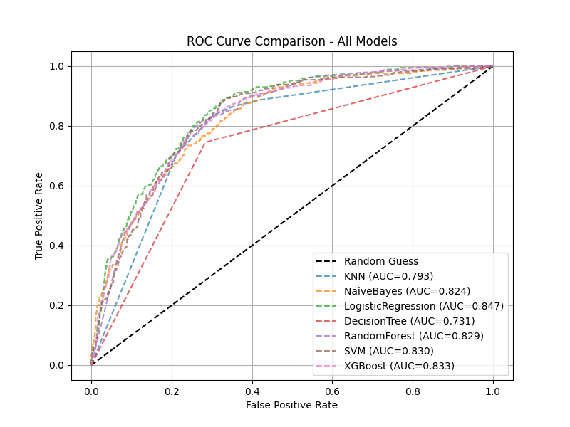

- KNN (AUC = 0.793)
Performs reasonably well but is sensitive to feature scaling and noise, limiting its discrimination power.
- Naive Bayes (AUC = 0.824)
Shows good performance despite strong independence assumptions, benefiting from well-preprocessed features.
- Logistic Regression (AUC = 0.847)
Achieves the highest AUC, indicating the best balance between true positive rate and false positive rate.
- Decision Tree (AUC = 0.731)
Lowest AUC due to overfitting and sensitivity to data variance.
- Random Forest (AUC = 0.829)
Improves over a single decision tree by reducing variance through ensembling.
- Support Vector Machine (AUC = 0.830)
Performs well in high-dimensional space but requires careful tuning and scaling.
- XGBoost (AUC = 0.833)
Strong non-linear learner with competitive performance, slightly below Logistic Regression.

Why Logistic Regression Is Selected as the Final Model
Selected Model: Logistic Regression (Tuned)
Justification:
- Achieves the highest ROC–AUC score (0.847) among all models
- Produces a consistently superior ROC curve across thresholds
- Provides probabilistic churn predictions useful for business decision-making
- Highly interpretable and easier to explain to non-technical stakeholders
- Computationally efficient and suitable for large-scale deployment

Business Interpretation (Telecom Churn Context)
A higher ROC–AUC means:
- Better identification of customers likely to churn
- Fewer loyal customers incorrectly flagged as churn risks
- More effective targeting for retention campaigns
Thus, Logistic Regression offers the optimal balance between predictive power and business usability.

Outputs of Model Selection & Evaluation:
After model selection and tuning:
- Best-performing model is identified using ROC–AUC
- Final tuned model is trained on processed training data
- Model performance is validated on unseen test data
- Output artifacts:
  - Trained churn prediction model
  - ROC–AUC score and evaluation metrics
  - Saved model object for deployment

Conclusion:
This project presents an end-to-end, automated machine learning pipeline for predicting customer churn in a telecom environment. Through exploratory data analysis, key churn drivers such as contract type, tenure, monthly charges, and payment method were identified, while demographic factors showed minimal influence.
The pipeline adopts a data-driven approach at every stage, automatically selecting optimal techniques for missing value handling, transformation, outlier treatment, encoding, feature selection, data balancing, and scaling. This ensures robust preprocessing, prevents data leakage, and preserves meaningful customer behavior patterns.
After evaluating multiple models using ROC–AUC, tuned Logistic Regression emerged as the best-performing model, offering strong predictive performance along with high interpretability. The final solution is scalable, reliable, and well-suited for real-world deployment, enabling telecom businesses to proactively identify churn risk and design effective retention strategies.

